AI-Driven SOC Automation Using Splunk for Intelligent Alert Analysis

Udutha shashidhar
shashi400066@gmail.com

The project to automate Security Operations Centers using Splunk is a step forward. It makes Security Operations Centers work better and faster. This system is like a helper that looks at security warnings and figures out what to do with them. It uses a tool called Splunk to collect and watch security events from over the organization. This means Security Operations Centers teams get information about possible cyber threats when they need it. The Security Operations Centers teams can then use this information to do something about these threats. The Splunk tool is very good at helping with this. The project is, about making Security Operations Centers better at dealing with security issues. Furthermore, the integration of automation workflows and artificial intelligence enhances the system’s capability by enabling intelligent alert analysis, severity assessment, and real-time notification. This automation reduces manual intervention, mitigates alert fatigue, and improves response time. In essence, the implementation of this AI-driven SOC automation solution offers organizations a comprehensive and scalable approach to proactively detect, analyze, and respond to security incidents, thereby strengthening their cybersecurity posture and ensuring continuous protection of critical digital assets in an increasingly complex threat landscape.
Keywords – AI-Driven SOC Automation, Splunk, SIEM, AI summarization, AI-based analysis, centralized monitoring, threat detection, workflow automation, real-time SOC alerts.

Introduction
"The project that uses Splunk for the AI-Driven SOC Automation is a way to look at and manage security events in companies. This project is made to help Security Operations Centers deal with the security alerts they get from different systems. The Security Operations Centers have a lot of work to do. The AI-Driven SOC Automation project uses Splunk to collect and look at logs from places and it can find things that are related and watch what is going on. This helps the AI-Driven SOC Automation project to look at security events and find potential cyber threats and things that seem suspicious. The Splunk tool is very useful, for the AI-Driven SOC Automation project. The project uses intelligence and automation to make security operations better. This means people do not have to get involved much and the responses are more accurate.
The cybersecurity practices are getting stronger because of this project. It helps keep the organizations assets from new threats that are always coming up.
This project is a step forward, for cybersecurity. It helps keep the organizations assets from threats that are always changing.
The AI-Driven SOC Automation system helps organizations to carefully look at security events that happen over their infrastructure.
It does this by watching everything from one place and using ways to look at logs.
The system helps find security incidents before they become big problems it summarizes them and looks at them closely.
The AI-Driven SOC Automation system also uses automation to make sure alerts are handled the way every time and that the SOC teams get them right away.
This means the SOC teams can react quickly to security incidents because they have the information they need from the AI-Driven SOC Automation system. The system uses intelligence to look at security logs and find things that are not easy to see. It helps us understand how attacks happen and how we can make ways to detect them. The system looks at security logs to get an idea of what is going on and it does this by using artificial intelligence to summarize and analyze the information. This helps us understand the behavior of attacks and make methods to detect security threats.
The proposed system is basically built on a foundation. This foundation is provided by Splunk. It helps to collect, store and look at security events from different places. These places include things, like applications, operating systems and network devices. It also looks at user activity logs and authentication services.
By using this system the people who watch over security called SOC analysts can see what is going on with security events more clearly. They can then do a detailed analysis of these events and do it more quickly. The proposed system is built on this Splunk foundation. The use of automation tools like n8n really helps to make the flow of security data easier. It does this by organizing how alerts are processed and sending information to be analyzed in a smart way. This makes it easier to deal with security data. The automation tools like n8n are very useful, for security data.
The AI-Driven SOC Automation system does a lot more than just collect. Look at logs. It also looks at alerts. Helps make decisions. The system uses intelligence to summarize things and look at threats. This means it can take raw security logs and turn them into information. The AI-Driven SOC Automation system uses intelligence to look at things and help figure out what is going on. It helps find patterns of attacks determines how bad they are and suggests what to do about them. This way the AI-Driven SOC Automation system can find problems before they become issues. It also means people do not have to look at everything so they are less likely to miss something important. The AI-Driven SOC Automation system is really good, at helping to keep things safe.
The proposed system is really good at helping with incident response and fixing problems. It sends alerts to the SOC teams so they can act fast. When all the information is, in one place and alerts are sent automatically through teamwork tools it makes it easier for security people to work together and figure out what is going on.
This way of doing things saves time when trying to find out what caused the incident. It also helps organizations to act and make strong decisions to stop threats and reduce the damage that can be done. The proposed system does this by making sure the SOC teams get the information they need.

In addition to improving threat detection and response, the AI-Driven SOC Automation project offers substantial benefits in terms of operational efficiency and compliance. Automated alert analysis and reporting support consistent documentation of security events, assisting organizations in meeting regulatory and compliance requirements. By reducing manual workloads and optimizing resource utilization, the system enables security personnel to focus on strategic security initiatives, continuous improvement of detection mechanisms, and strengthening the overall cybersecurity posture of the organization.

2. Techniques for AI-Driven SOC Automation using Security

2.1 Log Collection and Normalization:

Centralized SIEM logging: Leverage Splunk SIEM capabilities to collect and centralize security logs from multiple sources, including applications, operating systems, authentication systems, network devices, endpoints, and user activity, enabling unified visibility across the organizational infrastructure.

Log normalization: Normalize collected logs into a standardized format to support efficient parsing, AI-based summarization, analysis, and correlation across heterogeneous data sources.

2.2 Anomaly Detection and Event Correlation

Advanced Event Correlation:
Establish rules of correlation within the SIEM to define suspicious patterns and relationships for security events, such as failed login attempts, access anomalies, and network anomalies, in order to quickly identify potential threats.

Threat Intelligence Integration:
Incorporate threat intelligence feeds to enable the correlation of internal security events with malicious indicators, such as IP addresses, domain names, and attack patterns.

AI-based Anomaly Detection:
Employ AI analytical techniques to detect irregular events, or behavior that does not conform to baseline behavioral patterns, as a way of uncovering hidden security events that are not revealed via conventional rule-based methods.

2.3 Vulnerability Assessment and Prioritization

Identification of Sensitive Assets:
Evaluate security incidents and system events to determine assets vulnerable to threats, such as applications, servers, and high-level user accounts.

Risk-based Priorit
Prioritize the vulnerabilities on the basis of their severity, attempts made to exploit them, and their overall impact on the security of the organization.

AI-aided severity assessment
Apply AI Analysis to evaluate risk levels related to vulnerabilities and help teams in SOCs identify relevant strategies for response and mitigation measures.

2.4 Incident Response and Remediation:

Incident timeline and investigation:
Leverage the centralized log information of SIEM systems to build an incident response timeline, which will enable convenient investigation and facilitate the identification of root causes.

Automated remediation:
Trigger automated remediation actions based on predefined rules and AI-assisted analysis. This could include compromises such as system isolation, the capability to disable affected user accounts, or security alerts that could be triggered for further action.

Centralized security monitoring:
Leverage the SIEM platform to present a unified view of security events occurring organization-wide and enable SOC teams to detect threats with efficiency, respond well in coordination, and maintain better situational awareness.

2.5 Additional Techniques:

User and Entity Behavior Analytics:
Provide a deep-dive analysis of user and system behavior patterns to identify deviations from normal activity in order to help identify insider threats, compromised accounts, or privilege misuse.

AI-based summarization and analysis:
Leverage AI's power for summarizing security alerts, coupled with in-depth log data analysis to help SOC analysts reach the incident understanding sooner while making correct decisions.

Continuous Security Monitoring:
Carry out continuous and automated security monitoring. This will ensure real-time security event visibility for immediate detection, analysis, and response to potential security threats.

3. Existing System

The current system is mainly depending on a centralized security Information and Event Management system, such as Splunk, to aggregate, track, and analyze security events that are generated throughout the entire infrastructure of the organization. To be specific, the centralized system ensures that security events are unified and monitored, and as such, security operation teams can identify potential security threats based on rules and correlation mechanisms. For example, the current system, in spite of its capability to aggregate security logs from different sources, is highly manual in nature as security analysts are consulted to interpret security events and respond accordingly.

Though the present system is capable of monitoring activities in a central way, there are a few drawbacks to it. One of the significant disadvantages of the existing system is that it lacks the use of intelligent automation and AI, leading to a rise in the chances of fatigue-related alerts as well as ill-timed reactions to security events. Security analysts have the responsibility of monitoring a vast amount of security warnings, resulting in the process becoming a tedious, manual, as well as error-susceptible, task.

Additionally, the current system does not feature automation capabilities in incident handling. Although warnings are produced and viewed from the SIEM solution interface, manual processes exist in handling responses related to isolating malicious hosts or notifying responsible parties. The effect of this deficiency is that it slows down the incident handling process as well as decreasing the effectiveness of the security handling process.

To sum up, the current system is only dependent on a centralized SIEM tool for the analysis of security events and lacks the integration of AI-based intelligence and alert summarization. This makes the current system react largely to the evolving cybersecurity threats. Consequently, it is difficult for an organization to react quickly to the ever-growing cybersecurity threats.

3.1 Strengths:

Centralized Security Monitoring: The SIEM system, such as the Splunk system, offers a combined or centralized view of various security-related events that are generated in the organizational infrastructure, thus allowing efficient analysis and detection of possible security risks.

3.2 Weaknesses:

Alert analysis - manual:
The current system involves heavy manual evaluation of the alerts by the SOC analysts, thus resulting in a higher workload and delayed response to the incidents.

Limitations of automation capabilities:
Lack of automation and analytical capabilities using AI limits the capabilities of the system to effectively deal with large volumes of security events and dynamic security threats.

Delayed incident response:
The absence of automated remediation and intelligent prioritization negatively impacts the speed of response actions, potentially increasing the severity of incidents.

3.3 Potential Security Gaps

Reliance on Traditional Detection Techniques:
The lack of AI-summarization and intelligent analysis capabilities suggests rule-based detection methods are used, possibly ineffective against sophisticated or complex cyberattacks.

Limited contextual awareness:
This phase Ineffective automated context enrichment and analysis or correlation capabilities may lead to an incomplete understanding of a security incident and, as a result, missed critical threats.

How the AI-Driven SOC Automation Project can Resolve the Listed Challenges:

The proposed AI-Driven SOC Automation project will fill these gaps by incorporating the following capabilities:

AI-based alert summarization:
breakpoint detection, and Utilizes artificial intelligence to automatically summarize detected security threats, complex log data analysis, and offer contextual information to enhance detection accuracy and understanding.

Advanced threat detection:
Combines intelligent analysis with SIEM correlation to help detect complex patterns and behavior that could potentially go undiscovered in traditional methods.

Better response times:
The automation workflows provide fast alert processing and notifications, hence fast reaction capabilities for the Security Operations Centers in terms of reacting to incidents.

3.4 Limitations of the Existing System:

Lack of AI-based analysis:
The current system in use has not harnessed the capabilities of artificial intelligence in alert summary, context analysis, and severity evaluation, which affects its ability to manage sophisticated security events.

High dependency on human intervention:
The incident response process is slowed down, and manual examination and decision-making are necessary for most of the security alerts.

Scalability Challenges:
However, as the number of security events continues to rise, it becomes difficult for the system to scale, leading to slow analysis and lower efficiency.

4. Proposed System

The system will provide an AI-Driven SOC Automation framework that has the ability to improve the efficacy and efficiency of the security operation processes undertaken by the organization’s SOC. The system will integrate a Security Information and Event Management (SIEM) system such as Splunk and utilize automation and artificial intelligence to analyze, summarize, and notify the organization on the alerts generated by the system. In this way, the system will eliminate the associated inefficiencies of the current SOC system that lacks automation and utilizes human intervention processes that consume a lot of time.

In the new system, security events triggered from applications, operating systems, network equipment, and authentication services, as well as from user interactions, are collected in a centralized manner utilizing Splunk. The SIEM solution is applied in log aggregation, normalization, and correlation to determine abnormalities and probable security hazards. After recognizing a threat alert, the related log messages are delivered to an automation process for intelligent interpretation.

4.1 Enhanced Remote Management Capabilities

Improved Security Operations:
They can monitor security alerts as well as manage automation workflows from a central location, helping them take decisions instantly.

Centralized Alert and Action Management:
All security warnings, analysis results, and protection action advice are centrally managed to provide a unified and consistent protection stance for the organization.

Enhanced Administrative Efficiency:
Automation also eliminates the need for continuous human monitoring, which saves time and money. This also helps security personnel engage in other security initiatives.

4.2 Improved Response Time to Security Threats Today

Faster detection and alert analysis:
Artificial intelligence-based summarization and analysis make it possible to immediately interpret security incidents, which helps analysts in the security operations center understand the incident context and severity. Legal Status of Automation Fixed automation scenarios may launch reaction steps like warning escalation, account lock down notices, or isolation actions, thereby containing possible damage.

Real-time threat monitoring:
Continuous monitoring capabilities, including the delivery of real-time alerts, enable immediate action to security-related events.

4.3 Smooth Integration with Organisational Infrastructure

Centralized security management:
The proposed system will interface smoothly with the existing organizational infrastructure, such as servers, endpoints, authentication systems, and network devices, to provide a unified security management platform.

Reduced operational complexity:
Automation makes security workflows smooth and negates the administrative overhead for managing different independent security tools.

Enhanced visibility:
Offers a holistic and integrated perception of the overall security incidents within an organization, improving the situational awareness offered to SOC analysts.

4.4 Scalability and Adapt

Automatic scalability:
It is well-suited to scaling to accommodate a growing organization, with no adverse effect on system performance as it processes more security events.

Adaptability to evolving threats:
These AI models and detection algorithms may be updated to incorporate new threat intelligence and behavioral data in order to counter new kinds of cybersecurity attacks.

Less manual interaction:
Security analysis and alert handling procedures are now automated so that personnel can concentrate on advanced threat analyses and overall security optimization.

4.5 Analysis of Log Data

Log aggregation and normalization
Splunk receives security-related logs from multiple sources like applications, servers, network devices, hosts/endpoints, as well as authentication servers. Once received, the log files are normalized in terms of formatting into a standard form through the extraction of identifying details like source IPs, usernames, timestamps, types of events, as well as levels of severity.

Correlation and AI Threat Detection:
In general Once the data has been normalized, the Splunk system applies correlation rules to look for patterns of malicious activity. The events are then analyzed using summarization techniques based on AI analysis to discover complex scenarios of malicious activity that span layers of the infrastructure. The analysis provides a higher level of accuracy in identifying malicious activity while offering actionable information.

5. System Architecture & Workflow

The system architecture for the proposed framework of AI-Driven SOC Automation will be aimed at ensuring centralized security monitoring and automated notification for intelligent alert analysis. The system will be integrated with the components of data sources, the SIEM platform, automated workflows, artificial intelligence, and notification for the efficiency and scalability of the security operations.

5.1 System Architecture

The architecture has the following major components:

Log Sources:
There are varied log sources such as application, operating system, authentication service, network device, and endpoint sources that produce security events. Such security events include login, access, system error, as well as network events.

SIEM Platform (Splunk)
Splunk is a key component within the SIEM system that is involved in collecting, indexing, and processing the received logs. It is responsible for correlation and detection logic used in the identification of suspicious activities and possible incidents. The centralized approach used by Splunk provides visibility within the organizational infrastructure.

Automation Layer (n8n):
The automation layer is the one that manages the process flow of the alerts. After a security alert is created on the Splunk platform, the data of the relevant security alert is sent to the automation tool using the webhook feature.

Artificial Intelligence Analysis Engine:
This AI component does intelligent summarization and analysis for security alerts. It analyzes the log data that is correlated to provide valuable information such as contextual information of the alert, severity level of the alert, likely behavior of attacks, and response actions. This AI component helps security operation center analysts take decisions quickly and correctly.

Notification and Collaboration Platform:
Based on an analysis, the resultant alert information is then channeled to SOC teams via real-time notification systems. The approach ensures timely communication and quick responses to incidents.

5.2 Workflow of the Proposed System

The workflow in the AI-Driven SOC Automation system has a fixed sequence of steps:

1. Log Generation & Collection
Security events are produced based on various sources such as applications, servers, and network elements, as well as user behavior. The logging data is gathered and transmitted to the SIEM system for processing.

Step 2: Log Aggregation and Correlation
Splunk aggregates and indexes data from these logs by extracting useful information such as source IP address, username, timestamps, and events into which correlation techniques identify anomalies and trigger corresponding security alerts.

Step 3: Alert Forwarding to Automation Workflow
Identified alerts are then sent to the automation layer via a webinar interface that is a webhook.

Step 4: Summarization and Analysis
by AI The automation process transmits alert information to the AI analysis engine. The AI system completes the tasks of analysis and provides an understanding of potential threats to enable informed decisions on adequate responses.

Step 5. Alert Notification and Response
The analyzed and summarized alert is sent to SOC teams via real-time notifications. This allows analysts to examine the alert, initiate an investigation, and make necessary response actions.

5.3 Advantages of the Architecture

The proposed architecture provides centralized visibility, intelligent alert processing, and efficient automation of workflows. By embracing SIEM, automation, and AI, this system will reduce manual effort, enhance response times, and improve overall security posture.

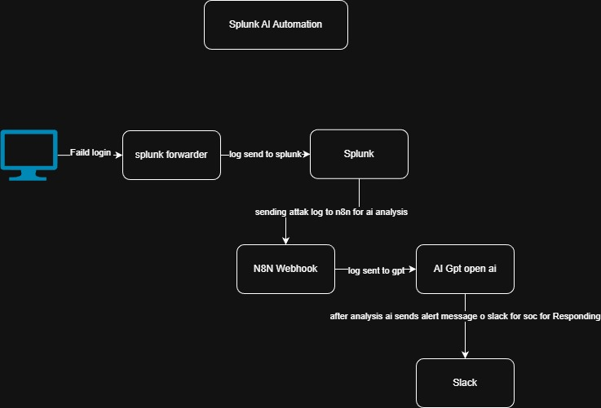

Figure 1: Architecture of Splunk Ai Automation

6.Results
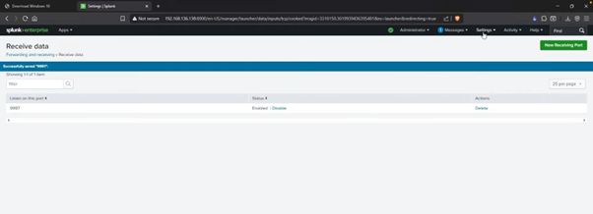
Figure 2: Splunk Forwarding and receiving port

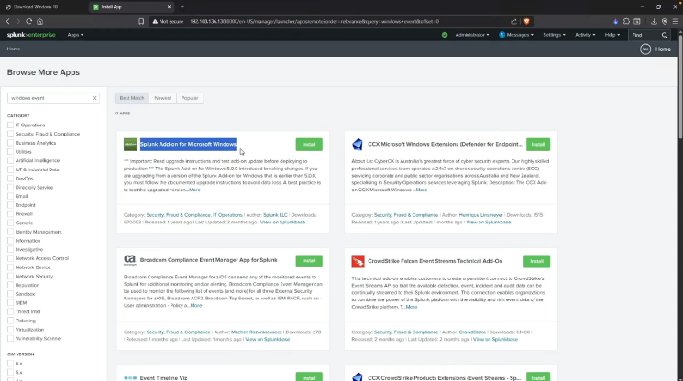
Figure 3: Microsoft windows add on

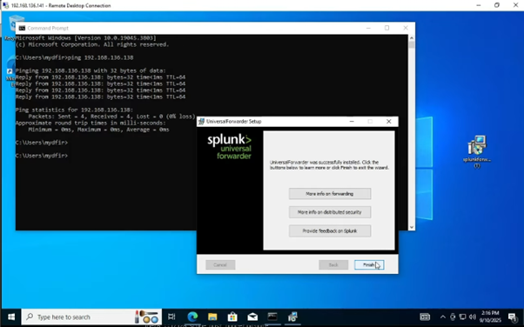

Figure 4: Windows forwarder agent installation

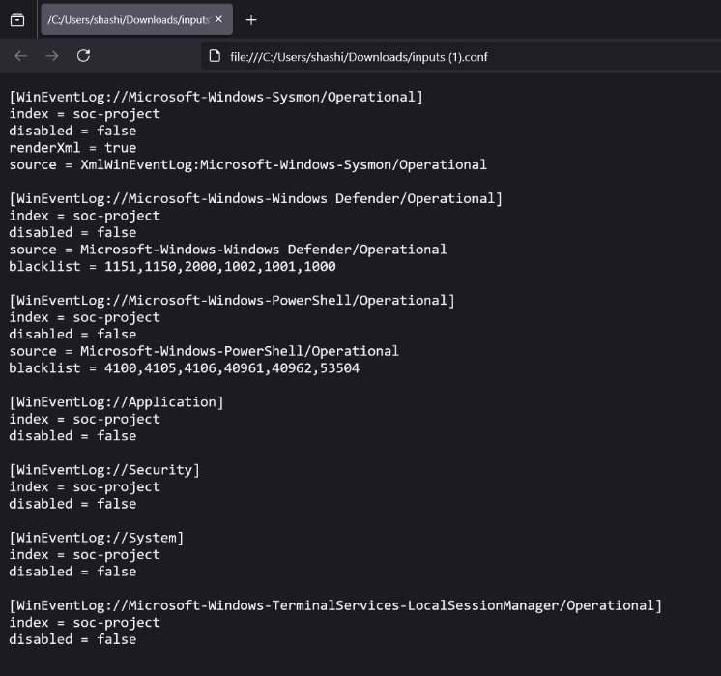
Figure 5 : log input file

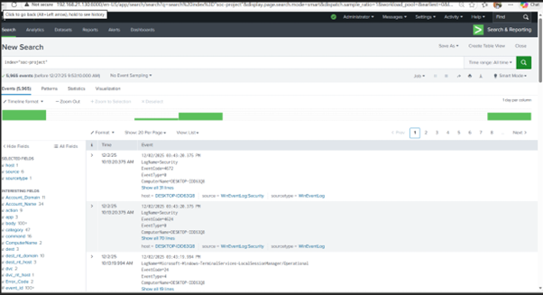
Figure 6: log collection from windows to Splunk

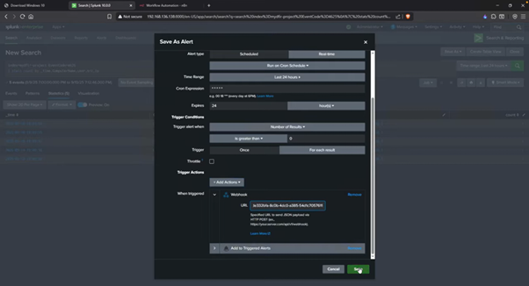
Figure 7: Webhook alert creation

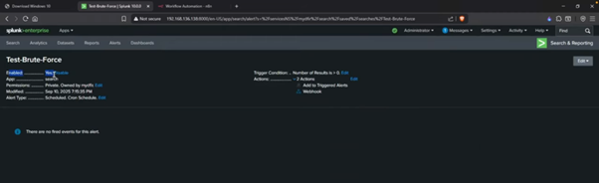
Figure 8 : Alert for Bruteforce attack

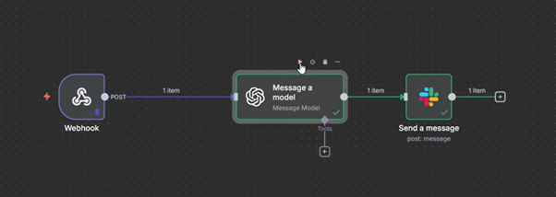
Figure 9 : Ai Automation Workflow

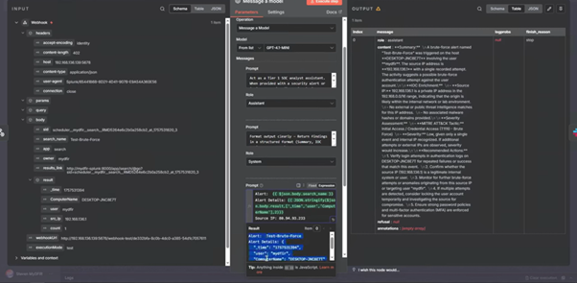
Figure 10: Detection flow

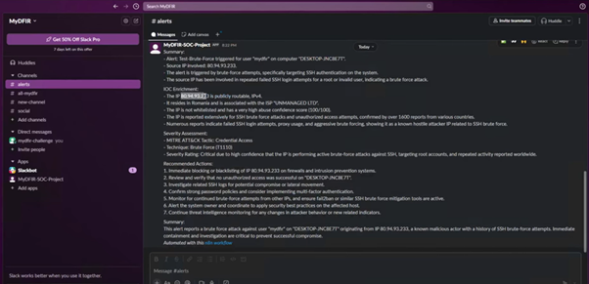
Figure 11: Slack Alert Message
7. Datasets for AI Driven SOC Automation Using SIEM Tool

7.1 Security Event Logs:

System Logs:
Operating system log records that contain information about system events, login attempts, errors, and security-related events that are used to identify abnormal activity patterns.

Applications Logs:
Application and web service logs, including user interactions, access attempts, errors, and application-level security events, which reveal insight into user behavior considered to be suspicious or unauthorized.

Network logs:
The types of logs that are retrieved from the network devices such as the router and the switch that are involved in the capturing of the entire traffic details and possible signs of an intrusion attempt on the network system that comprises the intrusion detection system

Firewall logs:
Firewall system logs containing information on the allowed and blocked traffic, connection attempts, or possible security intrusions.

7.2 Vulnerability Scanner Data

Scans performed using vulnerability scanning tools to point out system and application weaknesses, errors, and possible security holes. All such reports are useful when determining risk levels during security analysis.

7.3 Threat Intelligence Feeds

Real-time or aggregated threat intelligence data feeds that provide information on known threats, vulnerabilities, Indicators of Compromise (IOCs), and threat actor Tactics, Techniques, and Procedures (TTPs). These data feeds improve detection capabilities while enabling proactive threat discovery.

7.4 User Activity Data:

User behavior data includes log-in attempts, access requests, file operations, and session activities. This data is then analyzed to spot anomalies that may point to insider threats, compromised accounts, or unauthorized access.

8. Conclusion

SIEM is critically important in modern cybersecurity because it uncovers cyber threats and incidents through the collection and analysis of logs, followed by security management. Generally, what SIEM does is consolidate security events across multiple digital assets on a single platform for better visibility.

The proposed AI-driven SOC Automation system using Splunk extends the capabilities of conventional SIEM by incorporating automation and AI-based summarization and analysis. This integration enables faster interpretation of security alerts, reduces manual workload, and improves response efficiency. By leveraging centralized monitoring, intelligent analysis, and automated workflows, this system enhances proactive threat detection and bolsters the overall cybersecurity posture of the organization.

_references_

[1]. Mukesh Yadav, Dhirendra S. Mishra, “Study of challenges faced by Enterprises using Security Information and Event Management (SIEM),” Journal of University of Shanghai for Science and Technology, 2021, Vol. 23(08), pp. 511–522.

[2]. Sajad Homayoun, Ali Dehghantanha, Marzieh Ahmadzadeh, Sattar Hashemi, Raouf Khayami, “Know Abnormal, Find Evil: Frequent Pattern Mining for Ransomware Threat Hunting and Intelligence,” IEEE Transactions on Emerging Topics in Computing, 2020, Vol

[3] Giorgi Sharia, “Comparative Analysis of Enterprise Security Information and Event Management (SIEM) Solutions,” Thesis Report, Infotehnoloogia Teaduskond

[4] A. D. Moskvichev, M. V. Dolgachev, “System of Collection and Analysis of Event Logs from Sources under Control of Windows Operating System,” International Multi-Conference on Industrial Engineering and Modern Technologies (FarEastCon), 2020.

